Chapter 8, Problem 49.

Determine i(t) for t > 0 in the circuit of Fig. 8.96.

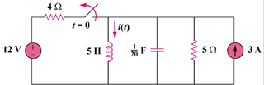

Figure 8.96
For Prob. 8.49.

